**End-to-End Observability of Full-Stack Applications Using New Relic**

**1. Introduction**

In the era of cloud-native applications and microservices, efficient monitoring is essential for ensuring performance, availability, and reliability. As businesses scale their applications using Docker and Kubernetes, traditional monitoring techniques struggle to provide deep visibility into containerized workloads, distributed applications, and dynamic infrastructures. This challenge calls for robust observability solutions that offer real-time insights, proactive alerting, and performance diagnostics.

New Relic, a powerful Application Performance Monitoring (APM) tool, addresses this need by providing end-to-end observability across containers, microservices, and infrastructure components. Unlike conventional monitoring tools, New Relic seamlessly integrates with Dockerized environments, offering deep insights into application behavior, resource utilization, network performance, and security vulnerabilities.

This paper explores how New Relic can be effectively used to monitor Dockerized applications in a production environment. We will walk through step-by-step integration, explain key monitoring metrics, and demonstrate how organizations can leverage New Relic’s alerting, logging, and visualization capabilities to maintain optimal performance.

By the end of this paper, readers will gain a practical understanding of how to implement real-time observability for containerized workloads using New Relic, ensuring high availability, reduced downtime, and enhanced operational efficiency.

**2. New Relic: End-to-End Observability for Modern Applications**

In today’s fast-paced software development landscape, real-time monitoring and observability are critical for ensuring optimal performance, reliability, and efficiency across diverse environments. New Relic is a comprehensive observability platform that provides deep insights into the performance of applications, infrastructure, and cloud-native workloads, making it particularly valuable for containerized environments like Docker and Kubernetes.

Unlike traditional monitoring solutions that focus only on basic CPU, memory, and network metrics, New Relic delivers a holistic view of system health by integrating application performance monitoring (APM), distributed tracing, infrastructure monitoring, and intelligent alerting into a single platform. This enables DevOps and Site Reliability Engineering (SRE) teams to detect issues proactively, optimize resource utilization, and prevent downtime in microservices-based architectures.

**2.1 Key Features of New Relic**

1. **Real-time Application Performance Monitoring (APM):** Continuously tracks application response times, error rates, and transaction throughput to detect performance bottlenecks.
2. **Infrastructure Monitoring:** Provides deep visibility into containerized workloads, virtual machines, cloud platforms (AWS, Azure, GCP), and on-premises infrastructure.
3. **Distributed Tracing:** Traces end-to-end user requests across microservices to help pinpoint slow dependencies, failures, and latency issues.
4. **Logs in Context:** Unifies logs, metrics, and traces in a single view, enabling efficient root cause analysis and troubleshooting.
5. **Intelligent Alerts & Anomaly Detection:** Uses machine learning-powered insights to detect anomalies, proactively triggering alerts before issues escalate.
6. **Custom Dashboards & Visualization:** Provides interactive dashboards that allow teams to monitor key performance indicators (KPIs) and system trends in real time.
7. **Auto-Instrumentation & Open Telemetry Support:** Seamlessly integrates with open-source observability tools like Prometheus, Grafana, and OpenTelemetry, ensuring flexible monitoring across hybrid and multi-cloud environments.

**3. Integrating New Relic with Dockerized Applications**

**3.1: Setting Up New Relic Account and License Key**

Before integrating New Relic with a Dockerized application, it is essential to ensure that the application is fully containerized and running smoothly within Docker. Additionally, the containers must be configured with the appropriate network settings to allow seamless communication between services.

The first step in the integration process is to create a New Relic account and obtain a license key, which is required to establish a connection between the New Relic agent and the New Relic platform for collecting application performance data.

**Steps to Set Up a New Relic Account and Generate a License Key**

1. **Create a New Relic Account:** Visit New Relic **Signup Page** to register for an account. Provide the necessary details and complete the signup process. Once registered, log in to your New Relic dashboard.

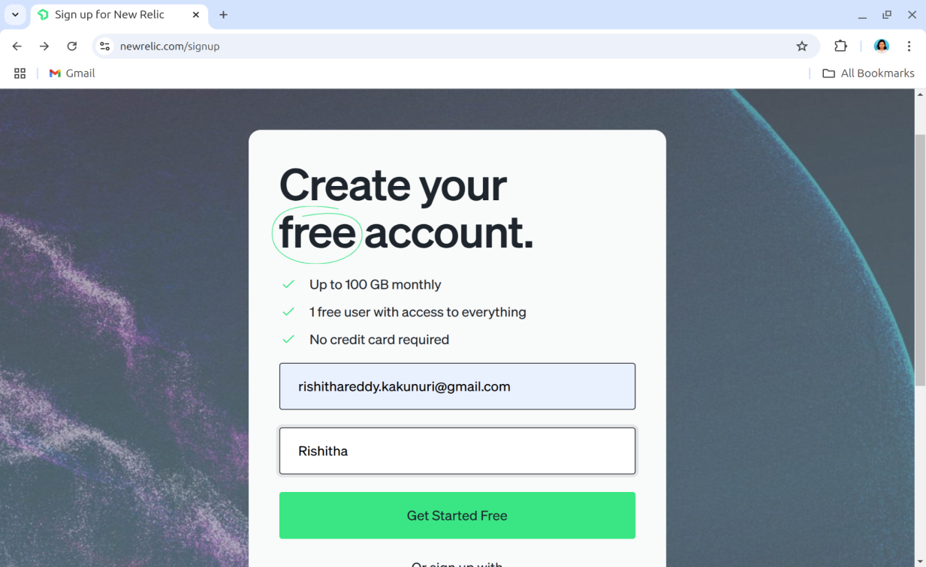

**Figure 1: Creating a New Relic Account**

1. **Access the New Relic Dashboard:** After logging in, navigate to the **New Relic dashboard**, where all monitoring entities and configurations are available.

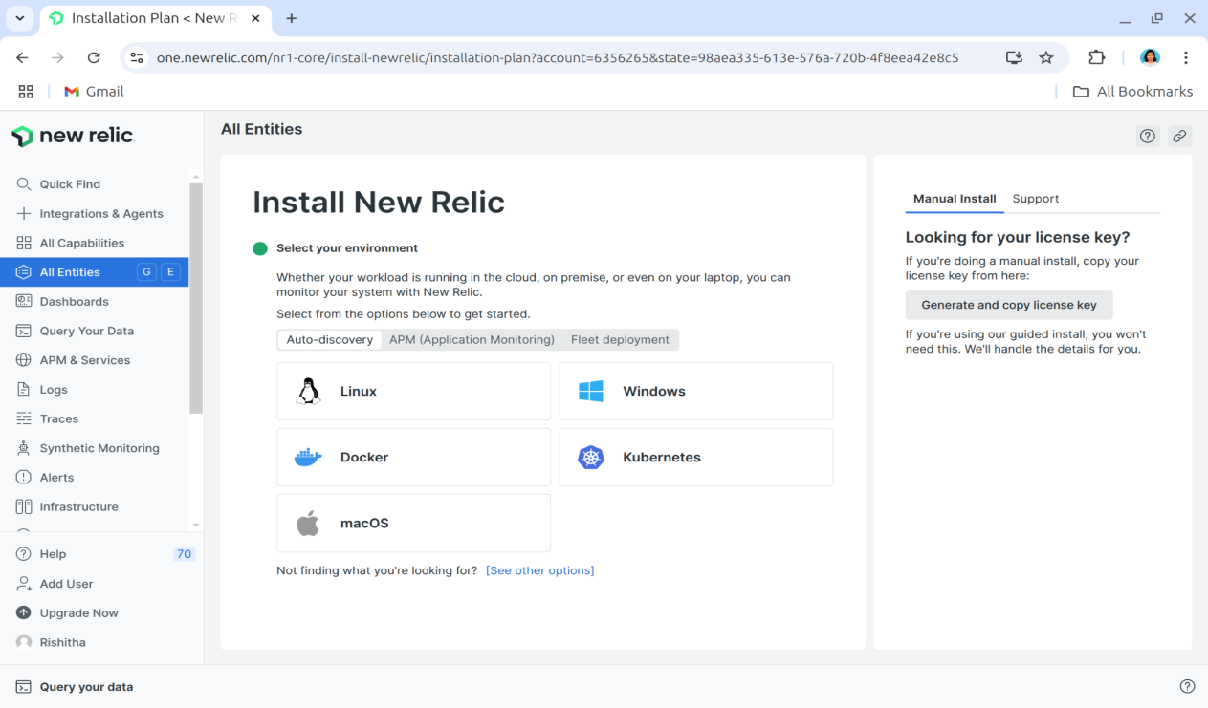

**Figure 2: NewRelic Dashboard with all the entities.**

1. **Generate a License Key:** Go to the **API Keys section** in your profile settings. Navigate to the **License Key tab** and select Create a New License Key. Copy the generated license key, as it will be required for agent configuration in later steps.

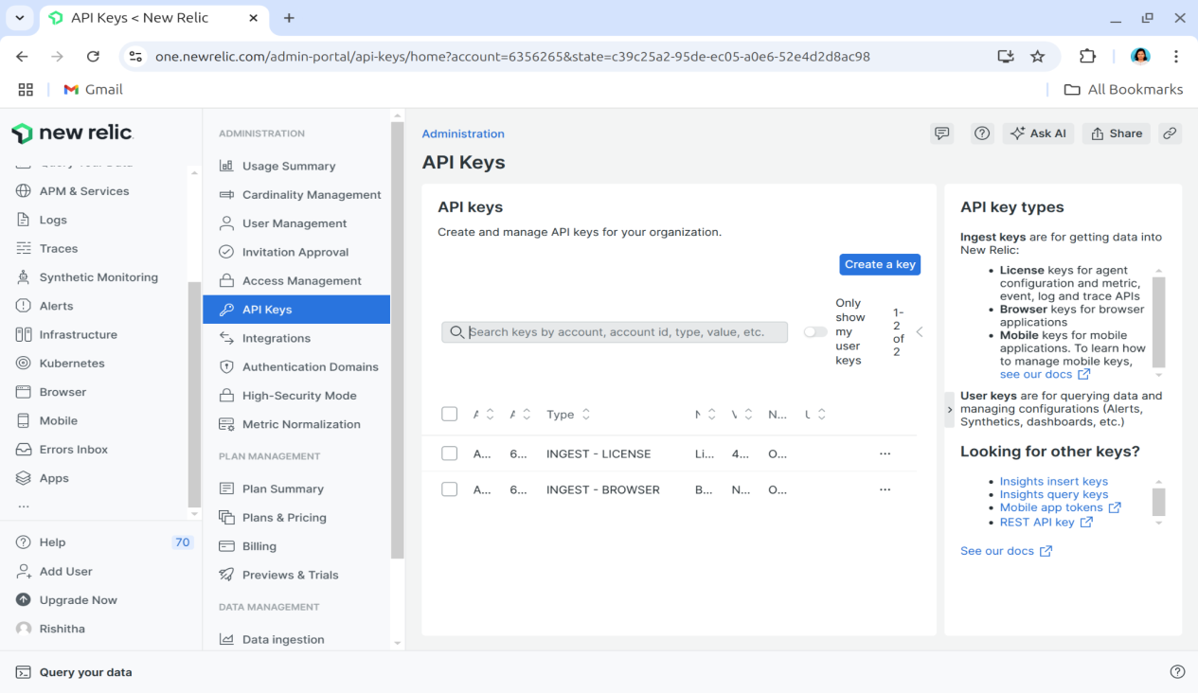

**Figure 3: Navigate to API Keys page to create new key.**

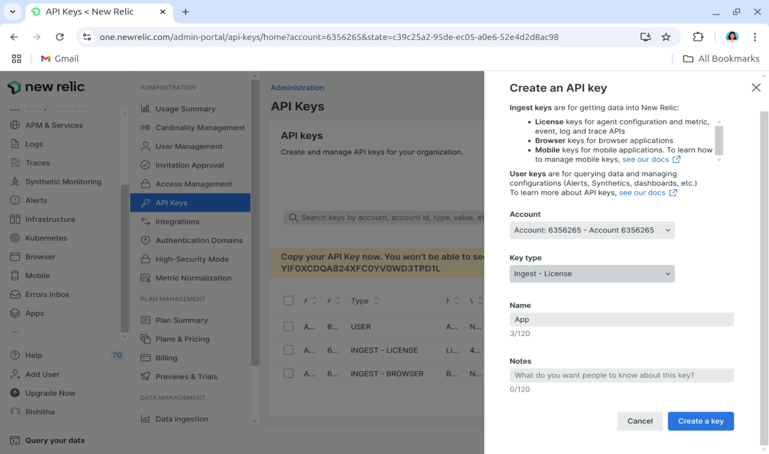

**Figure 4: Creating new license key**

This license key acts as an authentication token that allows the New Relic agent to collect real-time application performance data and send it securely to the monitoring dashboard.

**3.2: Java Agent for Backend Monitoring**

The backend of the application is built using Spring Boot and Java, running within Docker containers. To ensure real-time performance monitoring and proactive issue detection, the New Relic Java agent is integrated into the application.

This agent provides detailed performance insights, including:

* Response times, error rates, and throughput
* Database query performance and execution times
* JVM metrics such as garbage collection, heap memory, and thread activity
* External service interactions and API response times

By monitoring these critical metrics, the New Relic Java agent helps identify performance bottlenecks, optimize resource utilization, and enhance application reliability. Below is a step-by-step guide to integrating the New Relic Java agent with a Spring Boot backend running in Docker.

**Step 1: Select the Java Agent in New Relic**

1. Navigate to the **Integrations & Agents** section in New Relic.
2. Choose **Java** as the integration option.

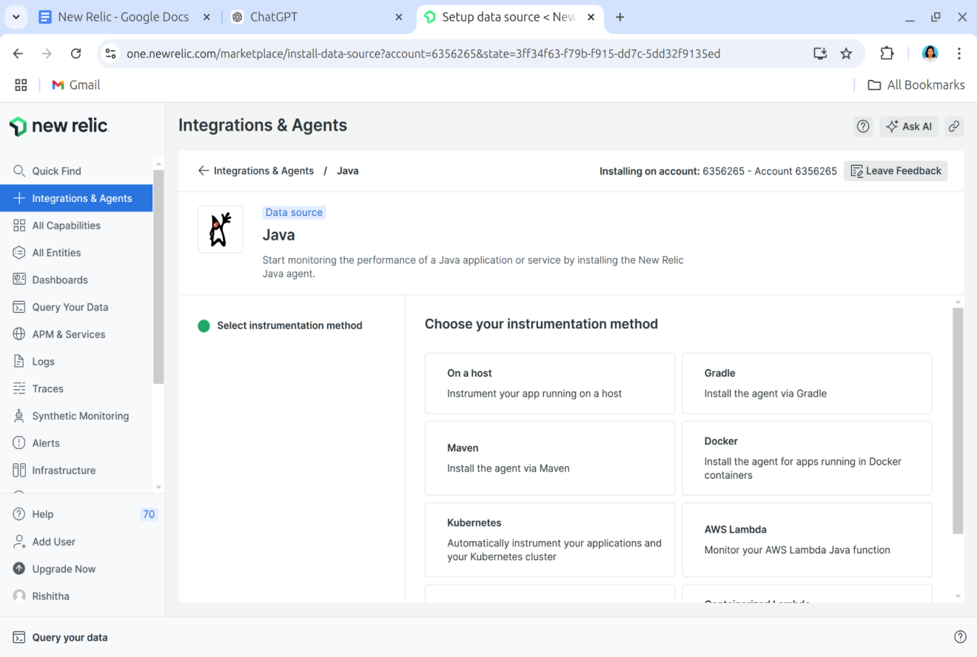

**Figure 5: Selecting Java Agent in New Relic**

**Step 2: Configure the License Key**

1. Select the environment where the application is running (in this case, Docker).
2. Enter the New Relic License Key generated earlier.
3. Click Continue to proceed.

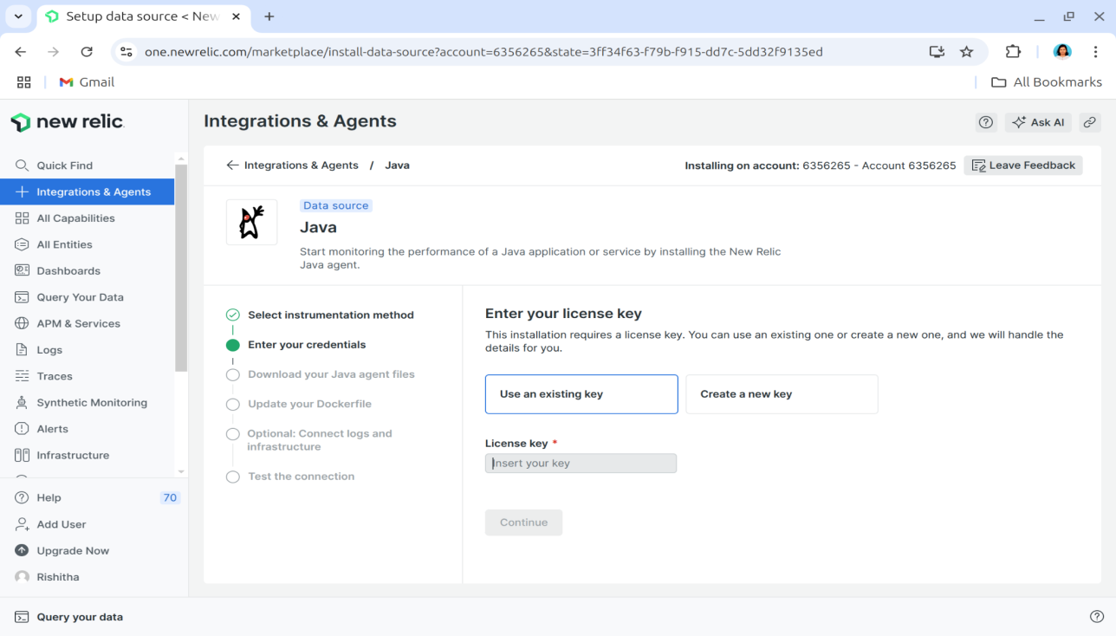

**Figure 6: Configuring the License Key for Java Agent**

**Step 3: Choose the Operating System**

* Specify the operating system of the application (for this setup, select Linux).

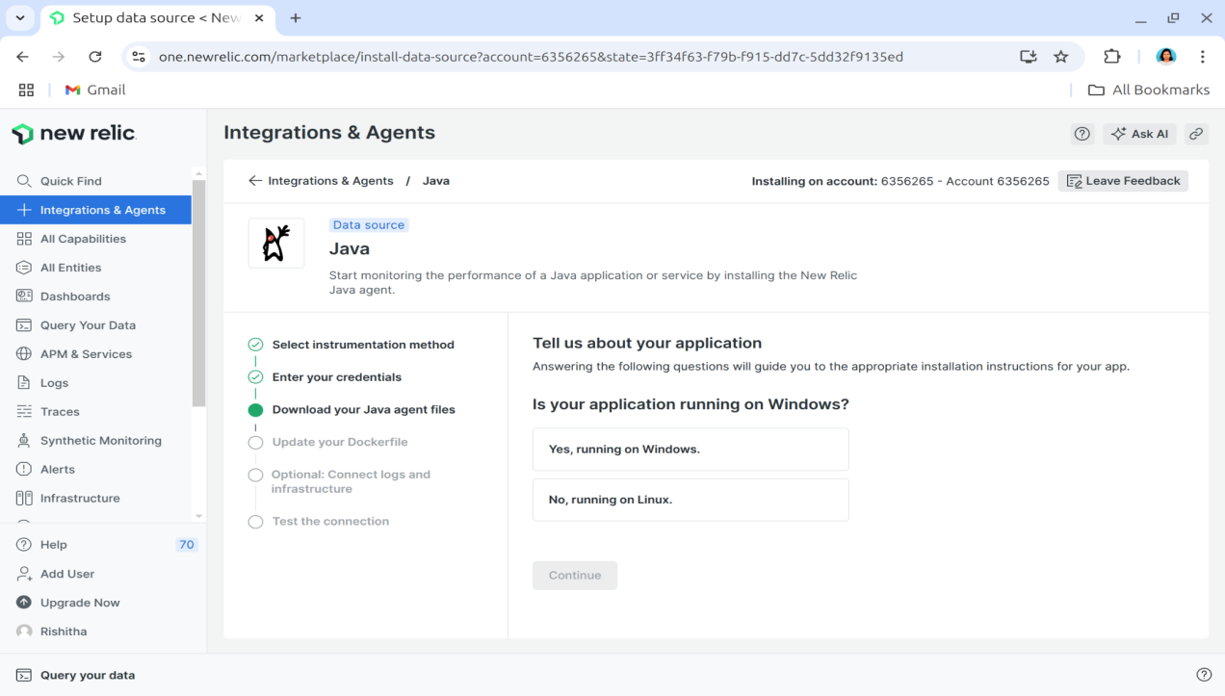

**Figure 7: Selecting the Operating System for Java Agent**

**Step 4: Download and Install the Java Agent**

1. Download the **Java Agent** using the provided command:
2. Extract the downloaded package.

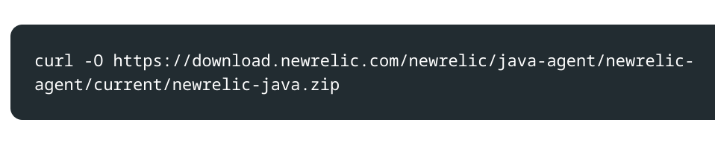

**Figure 8: Command for Downloading and Installing Java Agent**

**Step 5: Configure the Java Agent**

1. Assign a custom application name in the New Relic dashboard.
2. Download the New Relic **configuration file** containing your API Key.
3. Place this file inside the extracted Java agent directory.

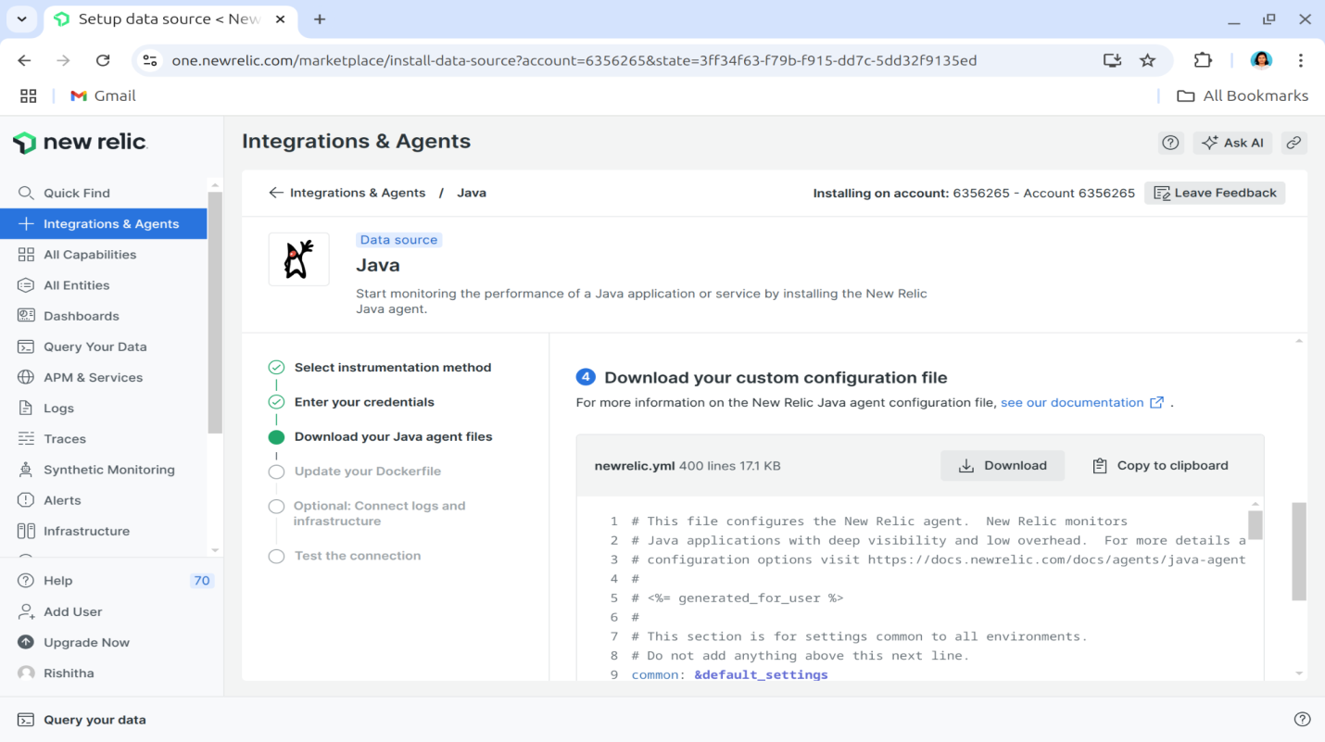

**Figure 9: Customizing the Configuration File with API Key**

**Step 6: Set Environment Variables in Docker**

To allow the New Relic agent to collect metrics, modify the Docker and Docker Compose files by setting **environment variables**:

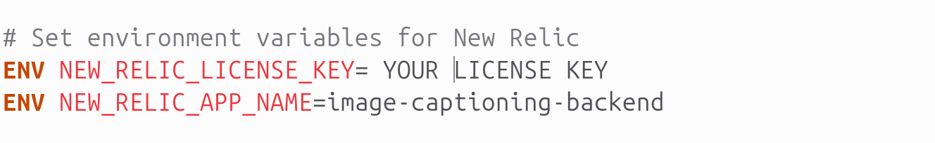

**Figure 10: Modifying Docker Configuration to Include API Key**

**Step 7: Update the Dockerfile**

1. Add the New Relic Java Agent to the Dockerfile.
2. Modify the startup command to include the New Relic Agent: 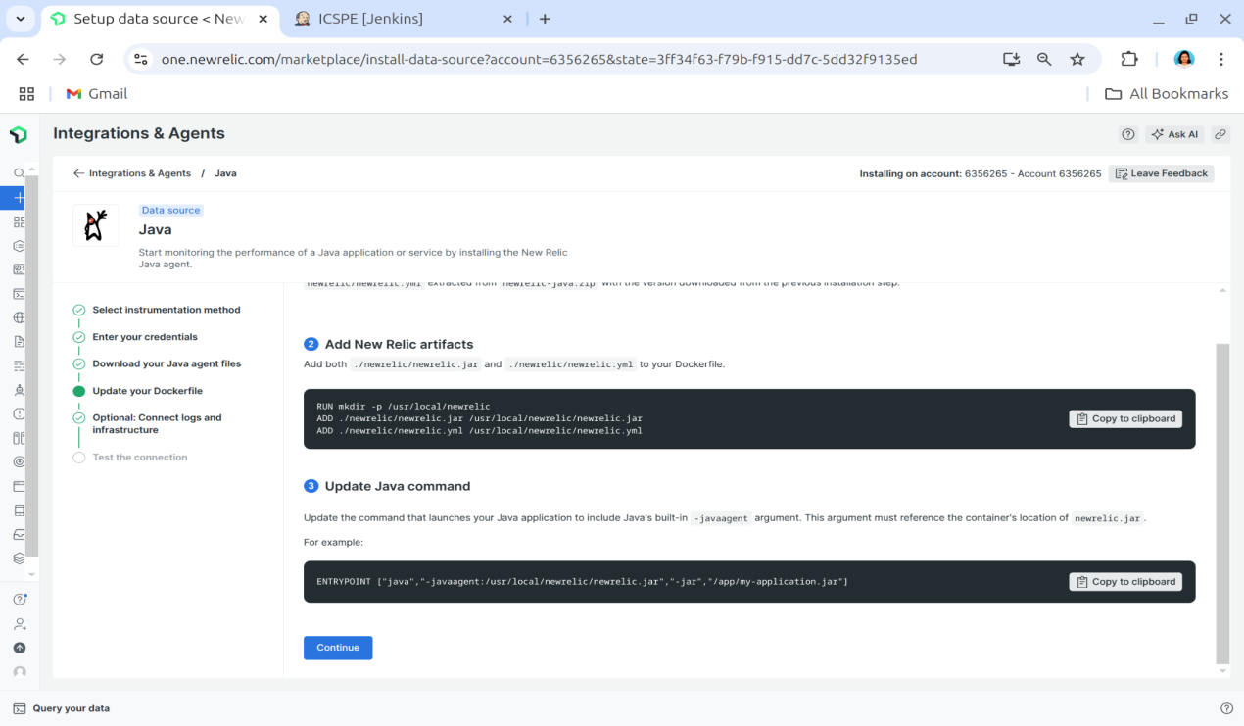

**Figure 11: Configuring Dockerfile with New Relic Agent**

**Step 8: Build and Deploy the Updated Docker Container**

1. **Rebuild** the Docker image: docker build -t my-springboot-app .
2. **Run** the container: docker run -d -p 8080:8080 my-springboot-app
3. Navigate to the New Relic dashboard and verify that performance metrics are being received.

Once the backend container is successfully integrated with New Relic, the dashboard shown in Figures 12(a-c) provide valuable insights such as:

1. **Response times & throughput** – Identifies slow requests and API bottlenecks.
2. **Error rates & exceptions** – Tracks application failures and logs stack traces.
3. **Database query performance** – Monitors slow SQL queries and optimizes database calls.
4. **External service interactions** – Ensures seamless API communication and third-party integration performance.

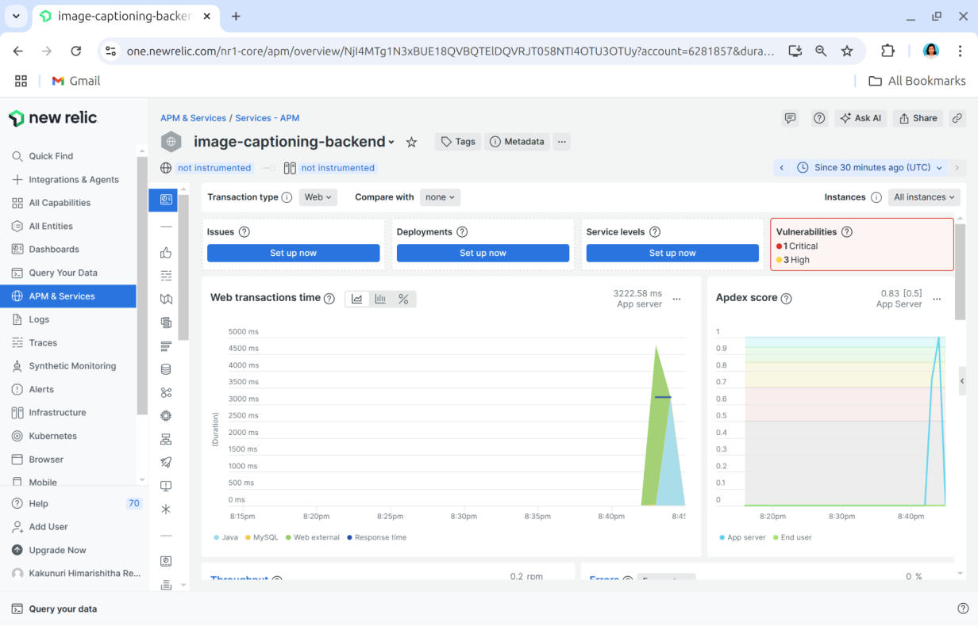

**Figure 12(a): Dashboard showing web transaction times, Apdex score, and detected vulnerabilities for the image-captioning-backend *service*.**

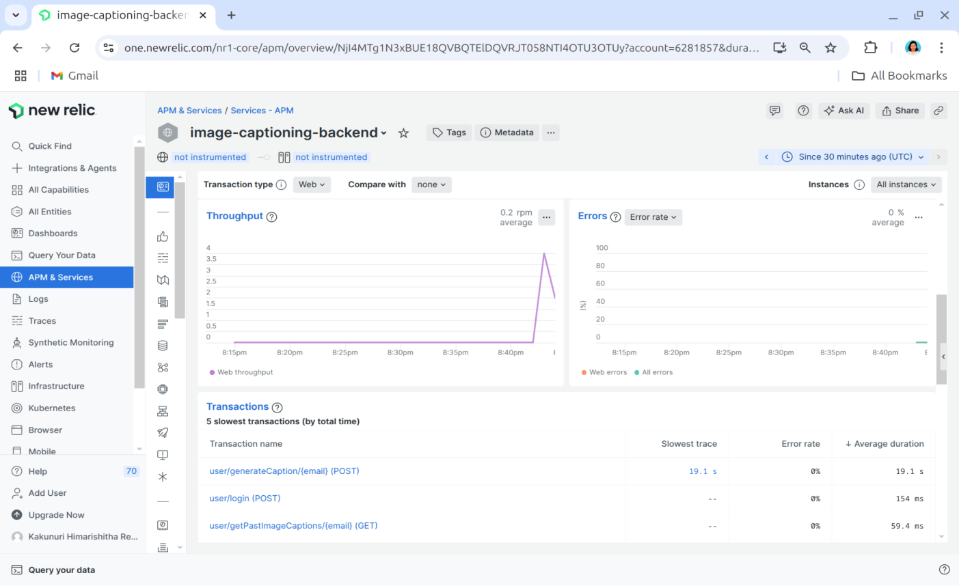**Figure 12(b): Dashboard displaying throughput, error rate, and slowest transactions.**

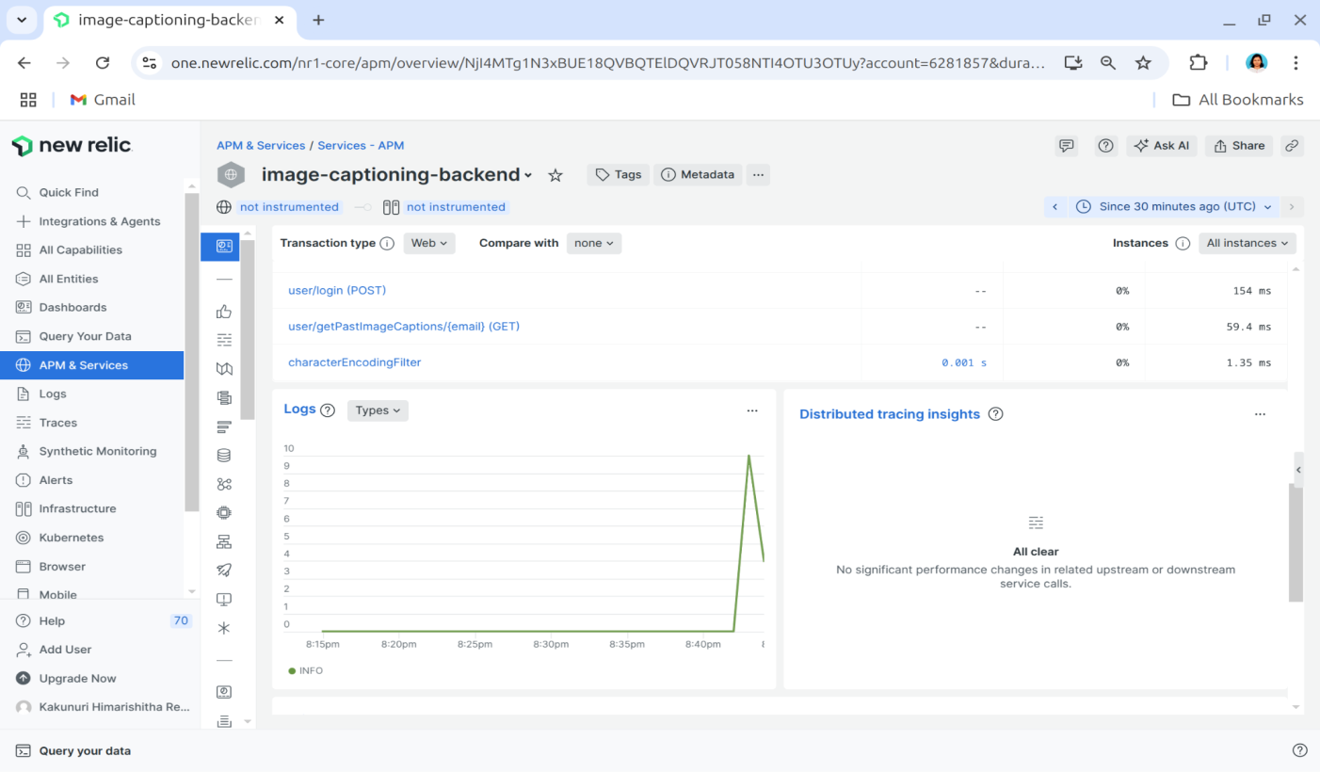

**Figure 12(c): Dashboard displaying transaction logs and distributed tracing insights.**

By leveraging real-time monitoring with the New Relic Java agent, developers can detect and resolve issues faster, optimize backend performance, and ensure a seamless user experience.

**3.3: Python Agent for Model Monitoring**

The machine learning model, developed using Python, is deployed within a Docker container running a Django application. To ensure optimal performance, the New Relic Python agent was integrated, providing real-time monitoring of model inference times, tracking Python process metrics, identifying bottlenecks, and ensuring the model serves predictions efficiently.

The following steps outline the process of integrating the New Relic Python agent with a Dockerized machine learning model hosted on Django.

**Step 1: Creating a New Relic Python Agent**

1. Navigate to the **Integrations & Agents** section in **New Relic**.
2. Select **Python** as the programming language.
3. Choose the **environment** where the application is running (**Docker** in this case) and click **Continue**.

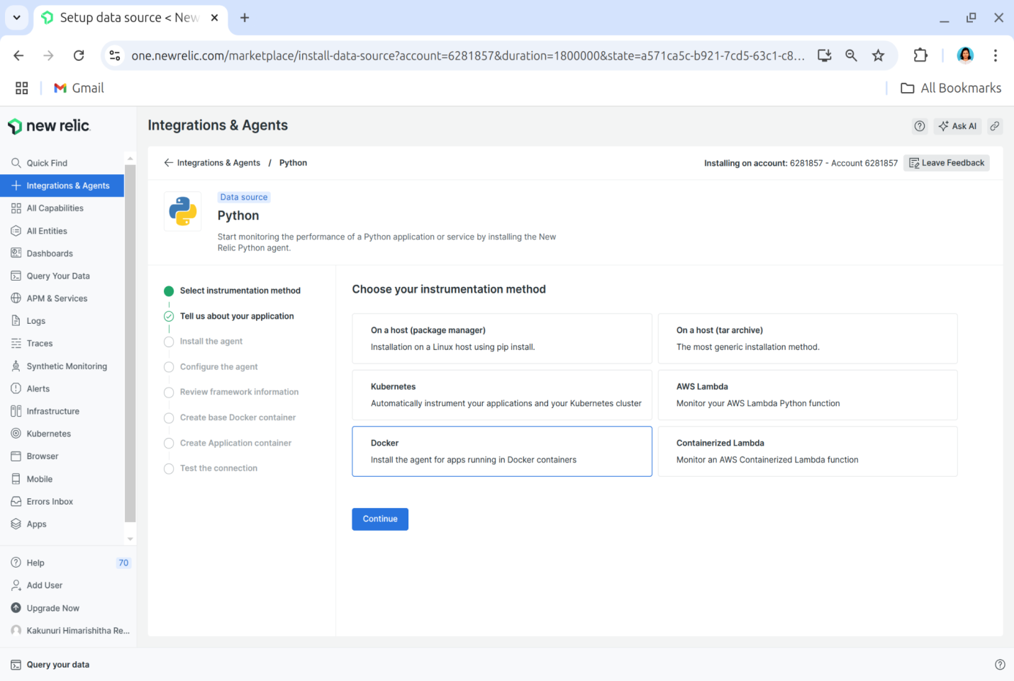

**Figure 13: Creating a Python Agent in New Relic**

**Step 2: Selecting the Application Type**

* Choose whether the Python model is a web application or a non-web application based on its functionality.

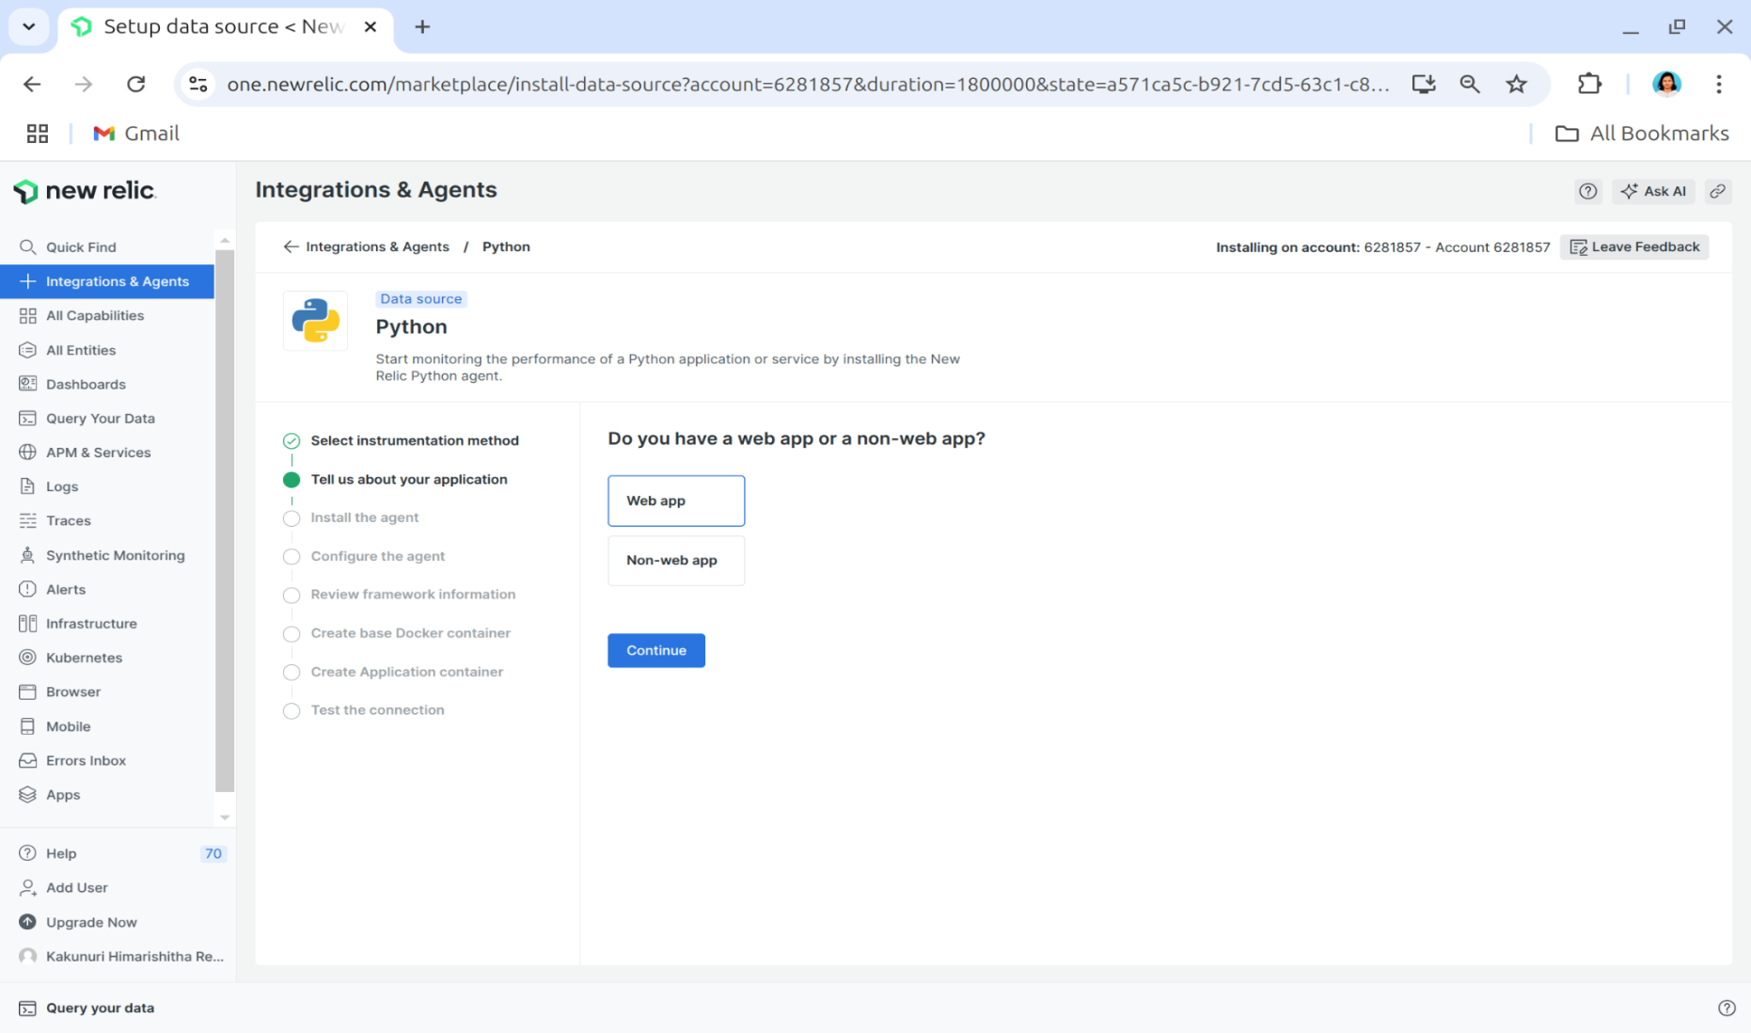

**Figure 14: Selecting the Application Type in New Relic**

**Step 3: Installing the New Relic Python Agent**

1. Ensure all required dependencies are listed in **requirements.txt**.
2. Install the New Relic Python agent using the command: pip install newrelic

**Step 4: Configuring New Relic for Python**

1. Create a New Relic configuration file by executing the command below as shown in Figure 15:
2. Customize the newrelic.ini file as required for the monitoring setup.

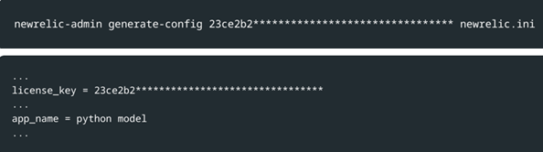

**Figure 15: Setting Up the Configuration File for the New Relic Python Agent**

**Step 5: Specifying the Framework**

* Select the framework used for hosting the model (Django in this case).

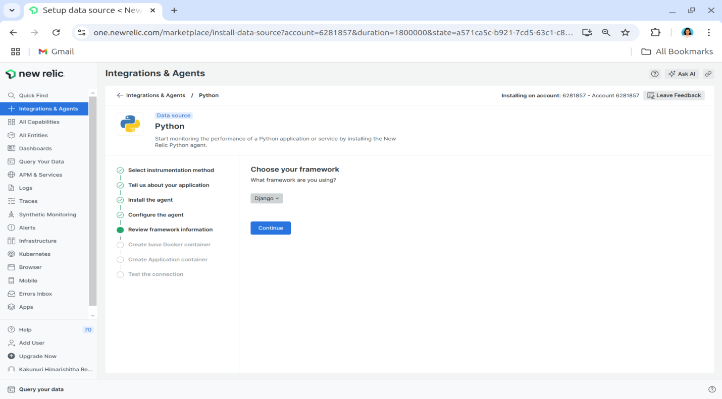

**Figure 16: Choosing the Framework for the Python Application**

**Step 6: Integrating New Relic with Docker**

* Modify the Dockerfile to:
  1. Copy the New Relic configuration file into the container.
  2. Use the New Relic admin tool to wrap the Django runserver command.

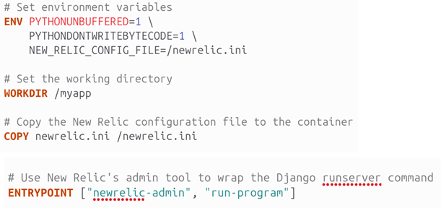

**Figure 17: Configuring the New Relic Agent in the Dockerfile**

**Step 7: Verifying the Integration in the Dashboard**

1. Select the Python server from the New Relic dashboard.
2. Build and run the Docker container.
3. Navigate to the New Relic dashboard to confirm the successful connection and review real-time metrics.

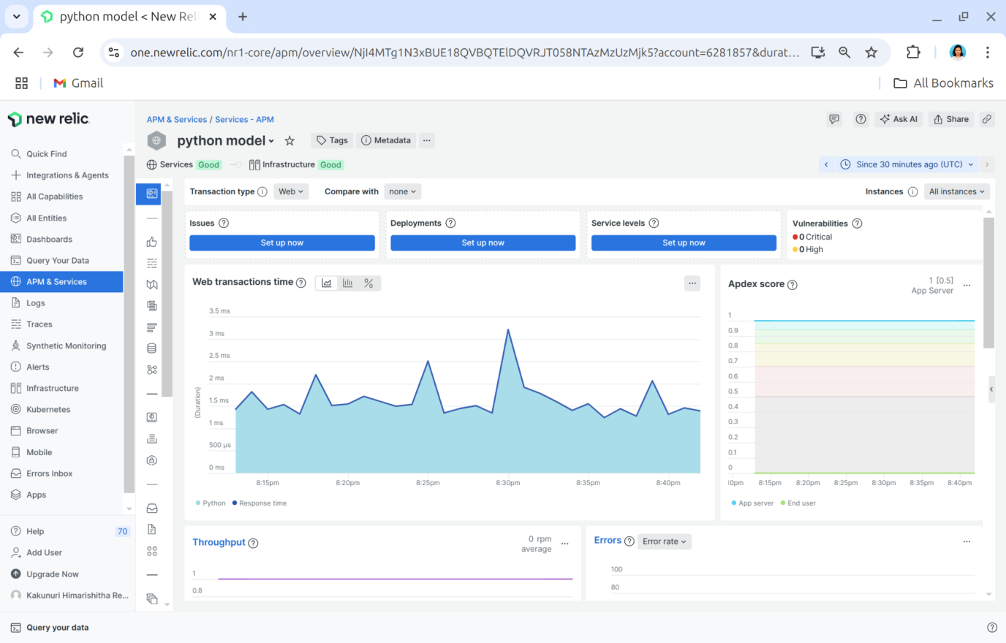

**Figure 18(a):** **New Relic dashboard displaying key Python application performance metrics, including response times, throughput, and error rates.**

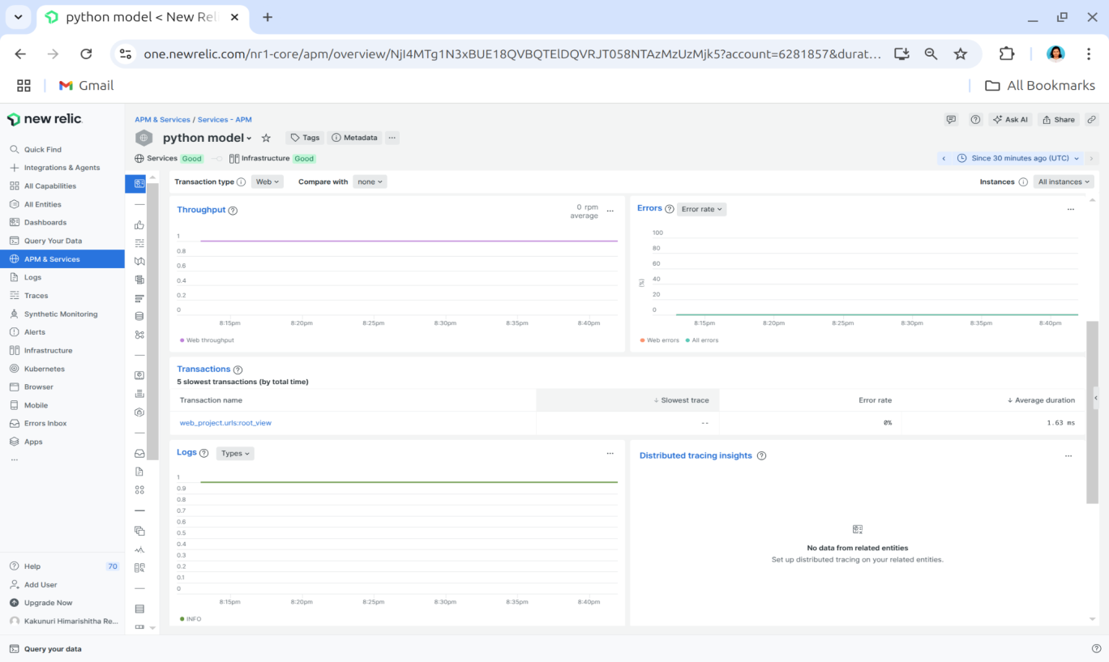

**Figure 18(b):** **New Relic dashboard showing all collected metrics for the Python application, providing insights into application health and performance trends.**

**3.4: Browser Monitoring for Frontend Application**

To ensure an optimal user experience, New Relic Browser Monitoring was integrated into the frontend application. This monitoring solution helps track real-user interactions, page load times, JavaScript errors, and frontend performance metrics, providing deep insights into how the application behaves in the user's browser.

Since the frontend application is built using React and deployed in a Docker container, New Relic Browser Agent was added to capture real-time performance analytics. The following steps outline the integration process.

**Step 1: Enable Browser Monitoring in New Relic**

1. Navigate to **Integrations & Agents** in the New Relic dashboard.
2. Select **Browser** **Monitoring** as the integration type.

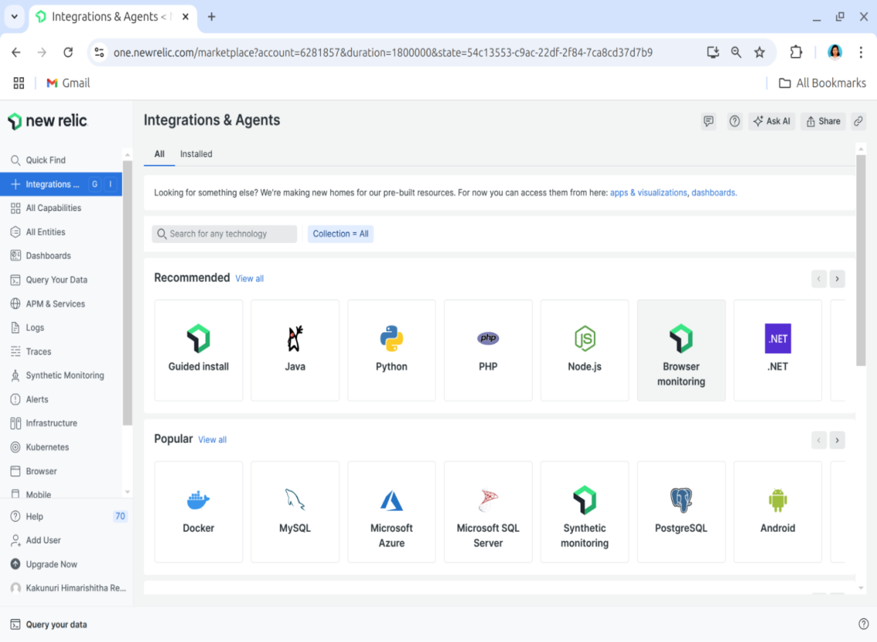

**Figure 19: Selecting Browser Monitoring in New Relic**

**Step 2: Choose an Integration Method**

1. Choose how the New Relic Browser Agent should be integrated.
2. Click Continue to proceed.

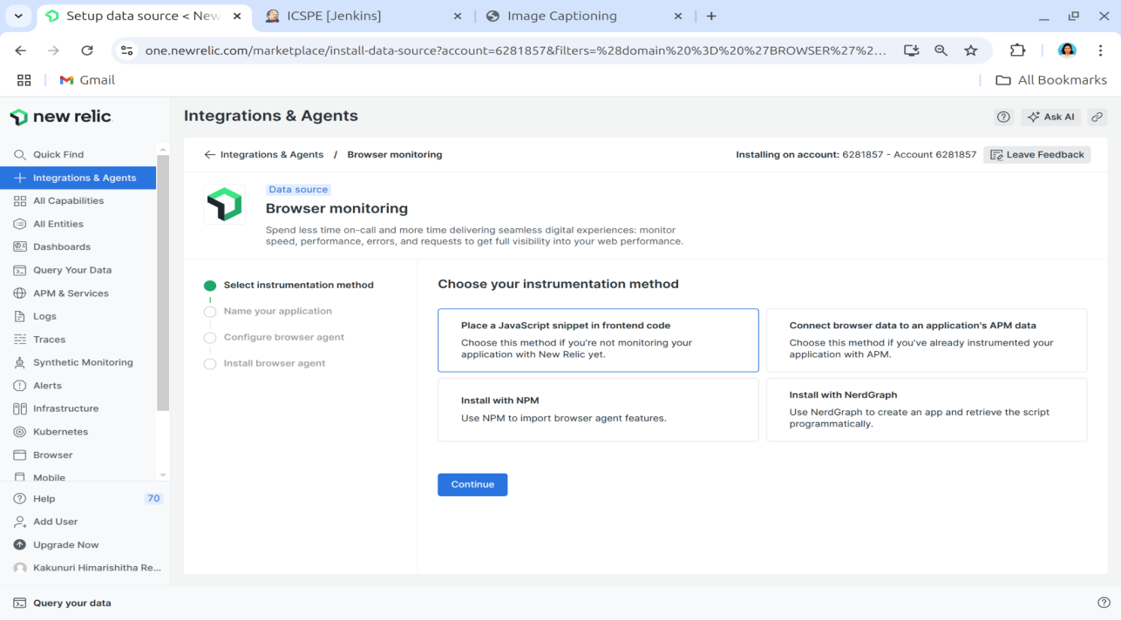

**Figure 20: Choosing the Integration Method for Browser Monitoring**

**Step 3: Configure the Browser Monitoring Agent**

* Assign a name to the frontend application for tracking in New Relic.

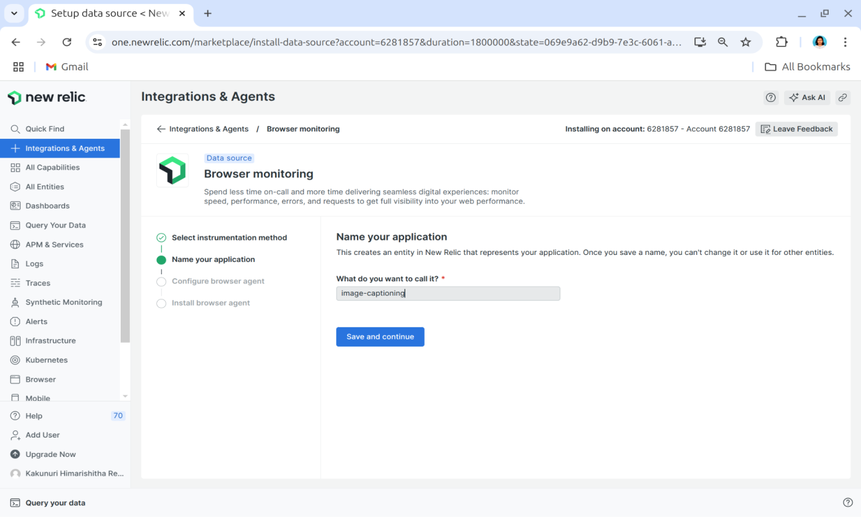

**Figure 21: Naming the Frontend Application for Monitoring**

* Define the monitoring settings based on the application's needs.

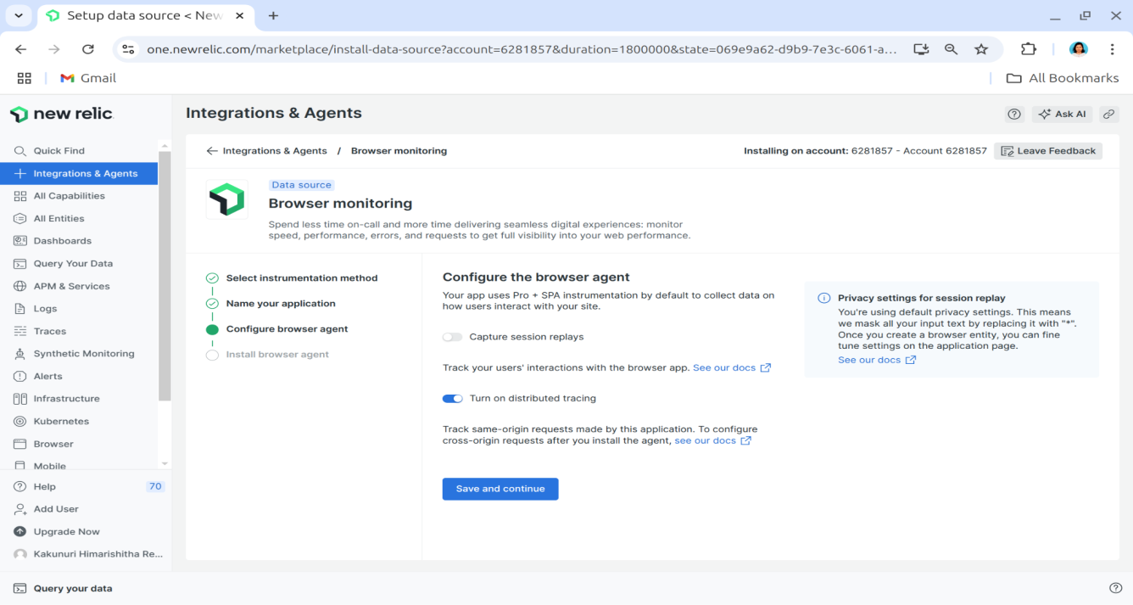

**Figure 22: Configuring the Browser Monitoring Agent**

**Step 4: Add the New Relic Agent Script to the HTML File**

1. Copy the **JavaScript** snippet provided by New Relic.
2. Insert the script into the **<head> section** of the HTML template in the frontend application.

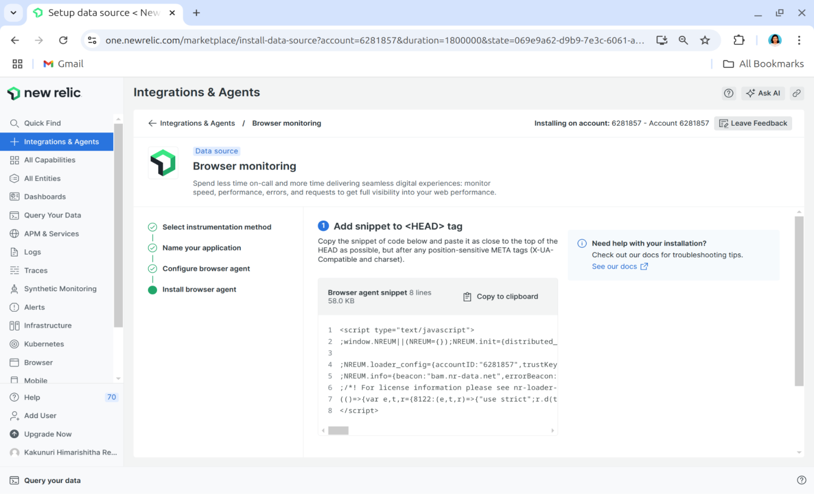

**Figure 23: Integrating the New Relic Browser Agent into the Frontend Application**

**Step 5: Build and Deploy the Frontend Application**

1. Build the Docker image for the frontend: docker build -t my-frontend-app .
2. Run the Docker container: docker run -d -p 3000:3000 my-frontend-app
3. Navigate to the New Relic Browser Monitoring section and verify that the frontend application appears in the dashboard.

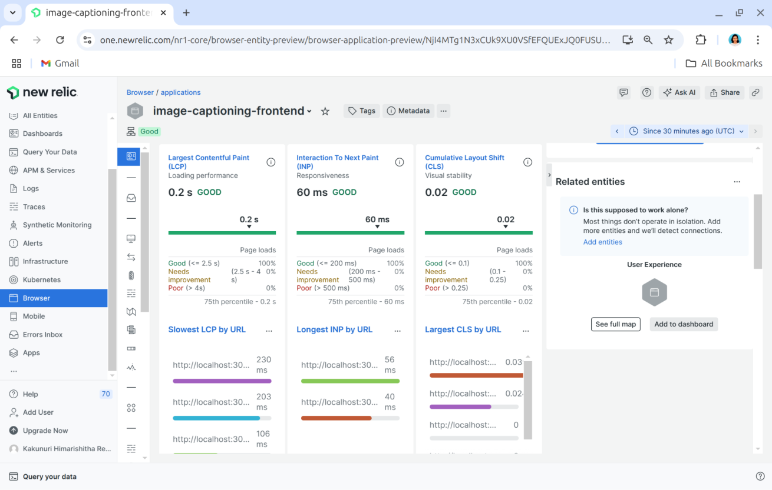

**Figure 24(a): New Relic Dashboard Displaying Frontend Page Load Metrics**

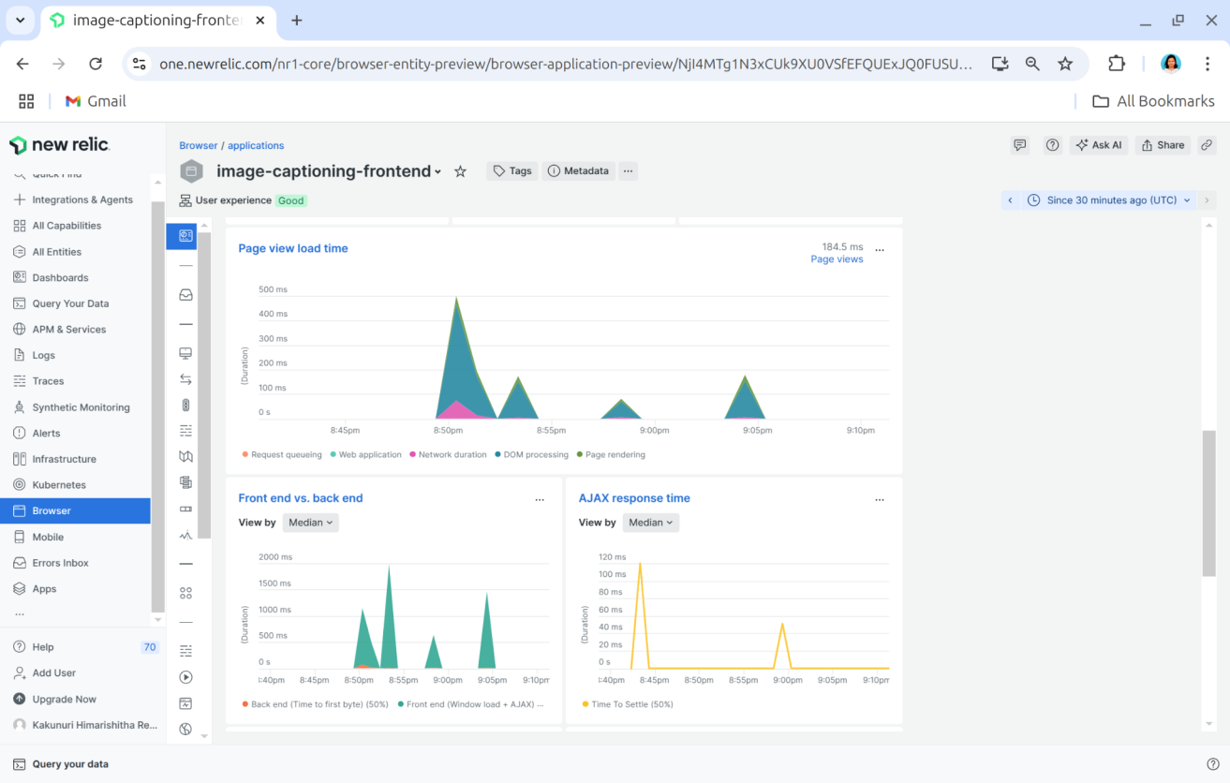

**Figure 24(b): New Relic Browser Monitoring dashboard displaying frontend performance metrics, including page load time, frontend vs. backend response times, and AJAX request performance.**

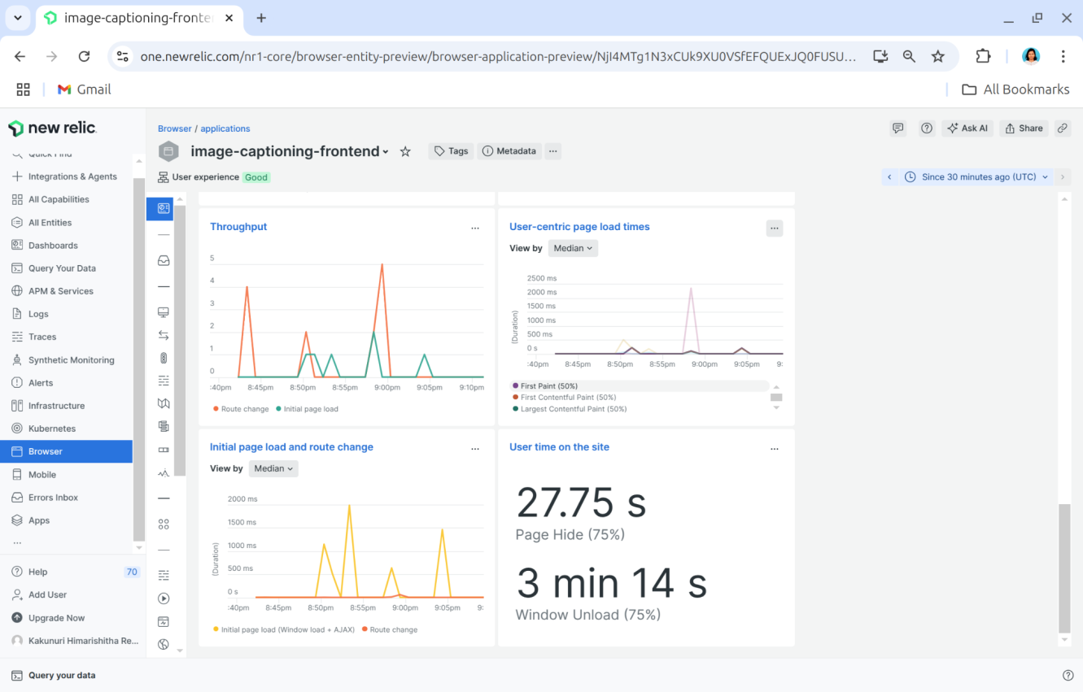

**Figure 24(c): New Relic Dashboard Displaying All Collected Metrics for Frontend Application**

**Key Performance Metrics Captured**

Once the browser monitoring integration is complete, New Relic collects real-time data on the following:

* **Page Load Times:** Measures how quickly pages render for users.
* **JavaScript Errors:** Captures and categorizes errors affecting the user experience.
* **User Interactions:** Tracks clicks, navigation, and engagement patterns.
* **Frontend Performance:** Monitors bottlenecks affecting responsiveness.

This data is visualized in the New Relic dashboard, enabling frontend teams to optimize performance, debug errors faster, and enhance the overall user experience.

**3.5 Infrastructure Monitoring**

Infrastructure monitoring is essential for tracking resource usage and performance across all containers in the system, including frontend, backend, and model services. New Relic’s Infrastructure Monitoring provides real-time insights into host-level metrics such as CPU usage, memory consumption, disk I/O, and network activity, along with container-specific metrics like per-container CPU and memory utilization, uptime, and restart counts. This comprehensive monitoring ensures stability and efficiency across all deployed services.

**Steps to Set Up Infrastructure Monitoring with New Relic**

1. **Install the New Relic Infrastructure Agent** using the following command: curl -Ls https://download.newrelic.com/infrastructure_agent/gpg/newrelic-infra.gpg | sudo apt-key add -
2. **Add the New Relic Repository** based on the appropriate Linux version: echo "deb [arch=amd64] https://download.newrelic.com/infrastructure_agent/linux/apt jammy main" | sudo tee /etc/apt/sources.list.d/newrelic-infra.list
3. **Update the package list and install the agent:** sudo apt-get update; sudo apt-get install newrelic-infra -y
4. **Configure the Infrastructure Agent:** sudonano /etc/newrelic-infra.yml

Add the following configuration:

license_key: YOUR_LICENSE_KEY

enable_docker: true

1. **Restart the agent to apply the configuration:** sudo systemctl restart newrelic-infra
2. Once the agent is installed and configured, navigate to New Relic’s Infrastructure Monitoring section to view all running Docker containers on the host.

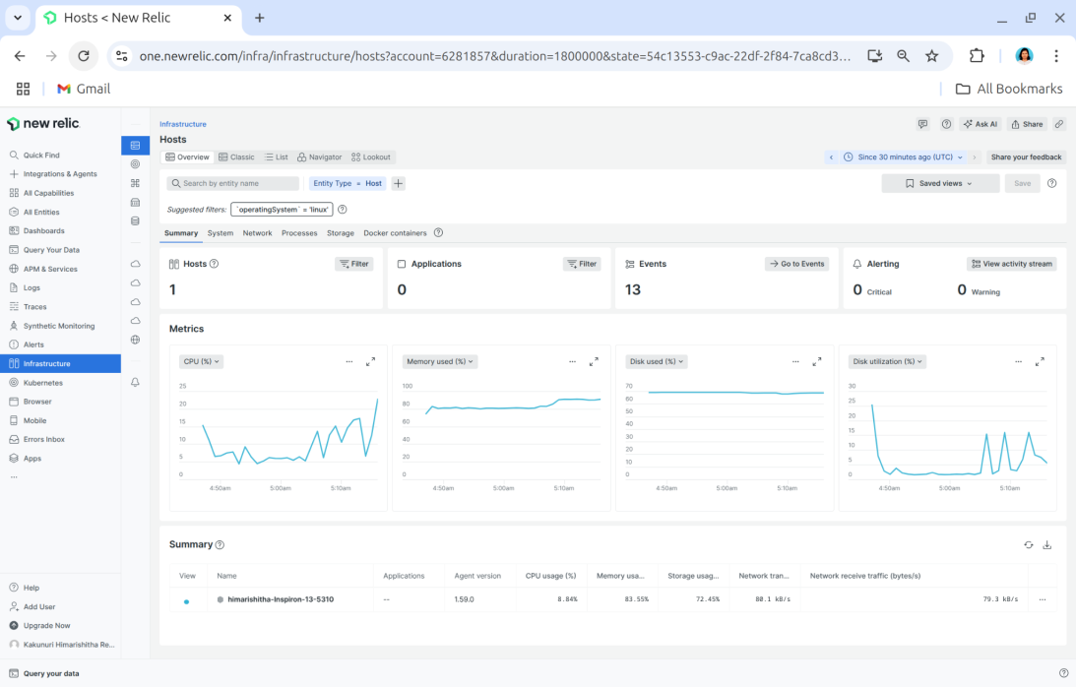

**Figure 25(a): New Relic Infrastructure Monitoring dashboard displaying an overview of all running containers.**

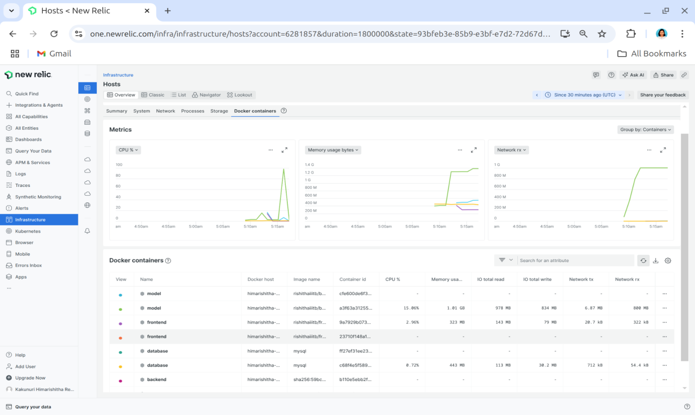

**Figure 25(b): New Relic dashboard showing detailed container-level metrics, including CPU usage, memory consumption, and network activity.**

**Container Monitoring and Metrics**

After setting up the agent, New Relic automatically detects and monitors all running containers on the host machine. The dashboard provides a comprehensive overview of container metrics, including:

* CPU usage and memory consumption for each container
* Disk I/O and network activity metrics
* Container uptime and restart counts
* Logs and performance data for frontend, backend, and model services

This enables real-time monitoring of the containerized environment, facilitating proactive issue detection and performance optimization.

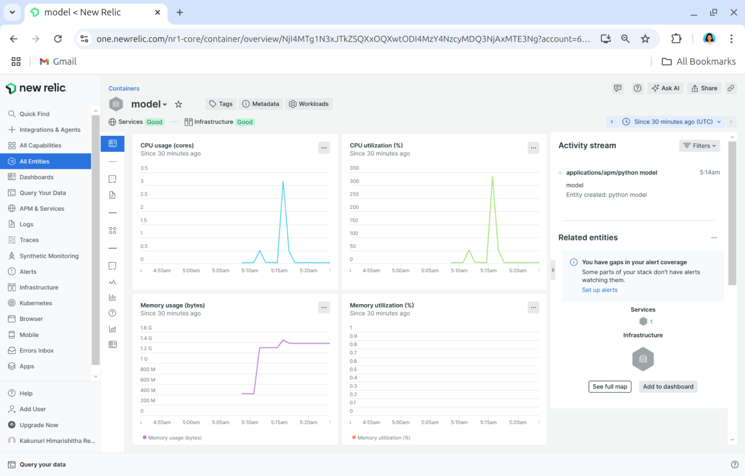

**Figure 26(a): New Relic Infrastructure Monitoring view for selecting a specific host running Docker containers.**

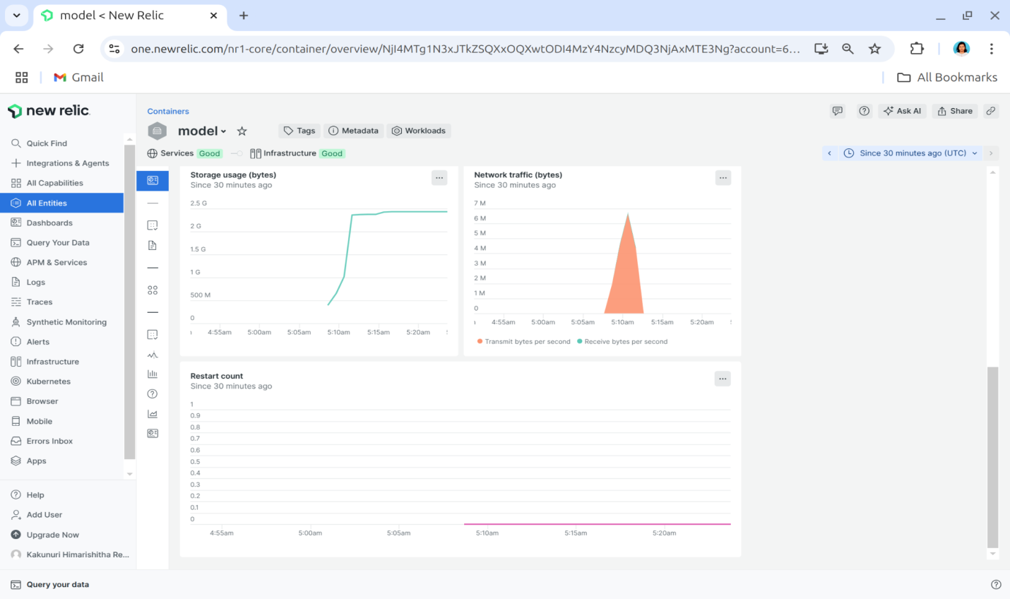

**Figure 26(b): New Relic dashboard displaying performance metrics for a selected Docker container.**

**Conclusion**

The integration of New Relic has significantly improved observability, performance management, and troubleshooting across the backend, frontend, machine learning model, and infrastructure. With real-time insights and proactive monitoring, the system ensures high availability and optimal performance.

New Relic effectively tracks backend response times, error rates, and database performance, while frontend monitoring analyzes user interactions, page load times, and JavaScript errors. The machine learning model, hosted on Django and Docker, is continuously monitored for latency and resource usage, ensuring AI-driven components remain efficient. Infrastructure monitoring provides visibility into CPU, memory, disk, and network usage, helping prevent bottlenecks.

With historical performance analysis and proactive alerts, the system enables trend identification, rapid issue resolution, and enhanced stability.

This paper demonstrates the importance of modern observability tools in maintaining scalable, high-performance applications. Real-time monitoring, intelligent alerting, and historical analysis play a crucial role in efficient troubleshooting, system resilience, and better user experiences in containerized environments.

**About the Authors**

**Kakunuri Himarishitha Reddy and B. Thangaraju**

The authors are associated with the Open Source Technology Lab at the International

Institute of Information Technology, Bengaluru (IIITB).